**RC, RL, and RLC transients**

Lab work done by:

Mitchell Wadle and Justin Pioquinto

Lab work date: 11/05/2019

Report submission date: 11/12/2019

Graded by:

Score:

**Introduction**

*\*one paragraph for introduction*

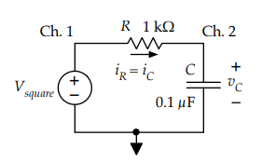**RC transients**

To started by building the circuit to the right

Source voltage:

Function generator square wave

Amplitude oscillates between 0 V and +10 V

Frequency = 500 Hz

1.

Calculated $V_{i}$ upward =

Calculated $V_{f}$ upward=

Calculated $V_{i}$ downward =

Calculated $V_{f}$ downward=

Calculated peak current (during transient) =

Calculated time constant (rising transient) =

Calculated time constant (falling transient) =

*\*sketches of expected upward and downward transients*

*\*calculations for above results*

2.

*\*trace of rise and fall from oscilloscope*

3.

4.

5. *\*compare measured results with expectations*

**RL transients**

**RLC transients**

**Conclusion**

*\*one paragraph for conclusion*